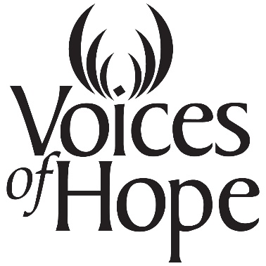

NEWS RELEASE
March 26, 2018
For Immediate Release

On Thursday, April 5, community members, college and high school students, and advocates will join together for two activities to raise awareness about Sexual Assault and its impact on our community as part of national Sexual Assault Awareness Month in April.
The first event is the third annual “End Rape on Campus” March. The march, which is supported by student organizations at such as PREVENT at UNL, the Gender Advocacy Place at Nebraska Wesleyan University, as well as students at Southeast Community College, Doane University and Union College, begins at 2:00 pm at the UNL Student Union Green Space (north of student union) and will conclude around 4:00 pm at the Nebraska State Capitol. Talks by survivors, advocates and the state legislator will begin the event at UNL Union Green Space and conclude the march at the capitol.
Thursday evening Voices of Hope is hosting the screening of the award-wining documentary, “The Voiceless” at 7 pm at the Ross Media Arts Center. The film features the stories of male survivors of sexual violence and explores the intersectionality between culture, masculinity, taboos and the impact that sexual violence has on men.
The documentary’s director and producer, Vanessa McNeal, and one of the male survivors from the film, Caleb Byer, will be present at the screening and will take part in a panel discussion immediately following its conclusion. McNeal won “Best Director” for the documentary at the Newark International Film Festival and received the Women Filmmaker Award of Recognition at Indiefest. Other panel members include Zac Palmer, Men's Program Coordinator in the UNL Women’s Center; T.J. McDowell, Title IX Coordinator at Nebraska Wesleyan University; Morgan Beal, Voices of Hope’s Coordinator of Campus Services; and Suzannah Rogan, Project Coordinator at Doane University.

“Sexual Assault Awareness Month presents an opportunity to raise awareness about sexual assault and its occurrence in our community. Statistics show that one in five that one in five women and one in 33 men will be sexually assaulted in her/his lifetime and its estimated that 60% of sexual assaults are never reported.” says Patsy Martin, Voices of Hope Communications Coordinator. “We know that sexual assault is under-reported, so we want people to know that our community supports survivors and that Voices of Hope is a safe and confidential place where they can turn for assistance and support.”

Admission to this event is free! For additional information, contact Voices of Hope at
402-476-2110.

#

For additional information, contact: Patsy Martin (patsy@voicesofhopelincoln.org) or Morgan Beal (morgan@voicesofhopelincoln.org) or call 402-476-2110.

